Lecture 4: In–Class Assignment

1. Prove that *E* (*aX* + *b*) = *aE* (*X*) + *b*, where *X* is a random variable, *a* and *b* are constants.

* We know that E (X) is called as the expectation of X.

And from the properties of expectations we get to know that,

$E\left(aX\right)=aE(X)$ <– Property 1

Also we know that, $E( \sum_{i}{a_{i}X_{i})= }\sum_{i}{a_{i}.E(X_{i}) }$ from Property 2 of expectation

We can write the above equation as follows:

$E\left(aX+b\right)=$ $- From property 2$

$E\left(aX+b\right)=aE\left(X\right)+b$ $- From property 1$

1. Write the cumulative distribution function for the probability distribution

p (x = 1) = 0.1

p (x = 2) = 0.3

p (x = 3) = 0.4

p (x = 4) = 0.2

* cdf (x) = $\left\{\begin{aligned}0.1 0≤x<1 \\ 0.4 1≤x<2 \\ 0.8 2≤x<3 \\ 1 3≤x<4\end{aligned}\right.$

1. In a study of battery life for laptop computers, researchers found that the probability that the battery life (L) will exceed 5 hours is 0.12. Three such batteries are used in independent laptops and we are interested in finding the probability that some x of the three batteries will last 5 hours or more.
2. Specify the standard probability distribution you will use to model this scenario.

* We can use binomial distribution for this problem.

1. What is the state space or the set of possible outcomes for this scenario?

* State space for the scenario is {0, 1, 2, 3}

1. Find the probability that only one of the three batteries will last 5 hours or more.

* Probability for only one of the 3 batteries will last for 5 hours is 0.278784..

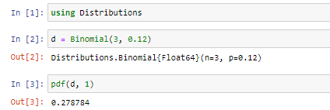

1. Write Julia code to plot the true distribution for all possible values of x.

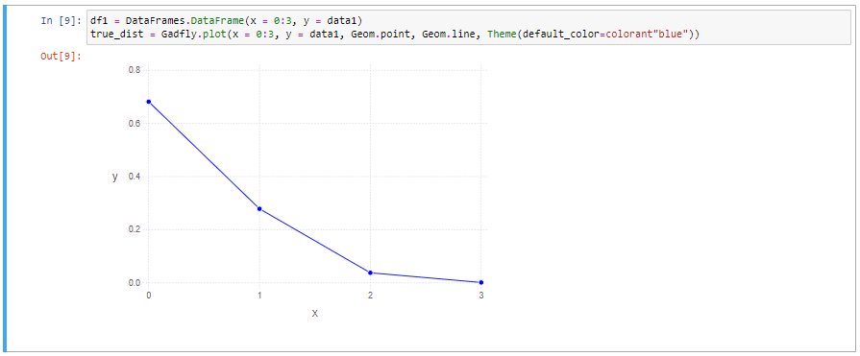

1. Write Julia code to sample 1000 points from this distribution and plot the empirical distribution

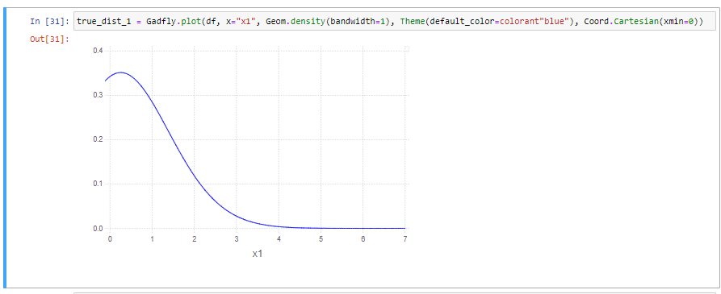

1. A statistically inclined farmer would like to model the number of grasshoppers per square meter of his rangeland. He is told that typically there are 0.5 grasshoppers per square meter on a rangeland.
2. Specify the standard probability distribution you will use to model this scenario.

* We can use Poisson distribution for this particular problem.

1. What is the state space or the set of possible outcomes for this scenario?

* State space for following problem is number of grasshoppers per square meter.

1. Find the probability that there are five or more grasshoppers in a randomly selected square meter region.

* Probability for 5 or more grasshoppers in randomly selected region is 0.00015795069263349796

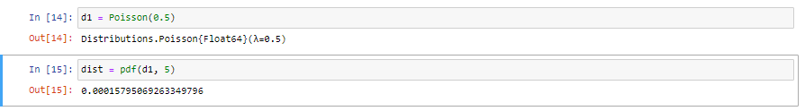

1. Write Julia code to plot the true distribution for values of x up to 10.

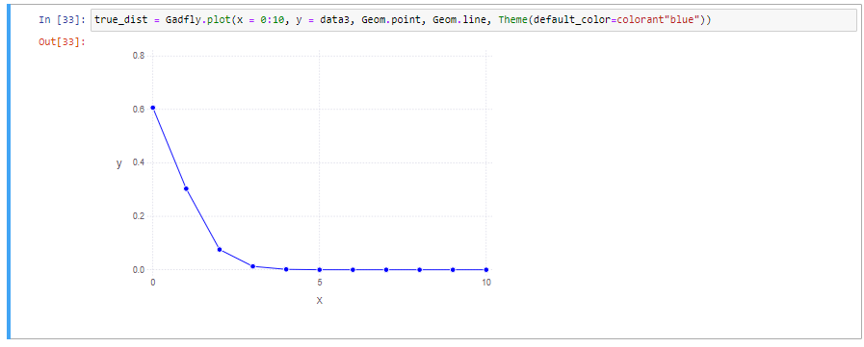

1. Write Julia code to sample 1000 points from this distribution and plot the empirical distribution.

